Manual 2
Test Document Hierarchy
What is your Organizations Test Documentation?
Test Policy – CEO

Test strategy – PM

Test Methodology – PM

Test Plan – Test Lead

Test case Scenario – Tester

Test case design – Tester

Test case review – Tester

Test case execution – Tester

Test Summary report – Tester

Test Defect report – Test lead

Test Closure report – Test lead

Test Policy
- It is company level document.
- Prepared by CEO of the Company.
- Objective, Aim or purpose of the project will be decided.
i.e How to earn more revenue, for which domain project will be good for us, this things will be decided by the CEO in this document.
Domain Includes – Banking domain , healthcare domain , insurance domain , E-commerce , Investment banking , telecom etc.

Test Strategy
- It is company level document.
- This document is prepared by Project manager.
- Test strategy is a set of guidelines that explains about the test design and determines how testing needs to be done.
- Components of Test strategy includes – Objective and scope, documentation format, team reporting structure, client communication, etc.
- A test strategy is carried out by project manager, It says what type of technique to be followed and which modules to be tested.

Test Methodology
- It is company level document.
- This document is prepared by Project manager.
- Test Methodology is derived from Test Strategy.
- In Test methodology testing types are used to certify that the application meets the client expectations.
- Depending on the project we can select respective strategy such as functional or non-functional testing, Security testing, Performance testing, API testing etc to validate the application

Test Plan
- Project level document
- Document prepared by Test Lead.
- Test Plan Includes Resource allocation, Job allocation and Estimation.
Resource allocation – Resources available for testing.
Job allocation – Tasks assign to tester
Estimation – In how much time task will be completed.

Test Scenario And Test case design
- In test case scenario and Test case design tester is involved.
- Here we identifies the test scenario and on that scenario we design the test cases.
- All the +ve and –ve test cases will be designed on a particular test scenario.

Test Case Review
- In Test Case Review all the written Test cases are reviewed By the Team.
- In Test Case review it is checked that all the Functionalities are covered in it or not.
- There are various types of reviews Conducted in Test case review Such as Self review, Peer review, Internal review and External Review.

Test Case Execution
- In Test Case execution Tester is involved.
- In this whatever test cases we have designed we will be executing that test cases on our developed application.
- In test case Execution We prepare test proof document.

Test Summary Report
- Project Level Document.
- Document is prepared By tester.
- In this report we will be keeping the track of Test case design (TCD) , test case execution (TCE) , how many defects locked.
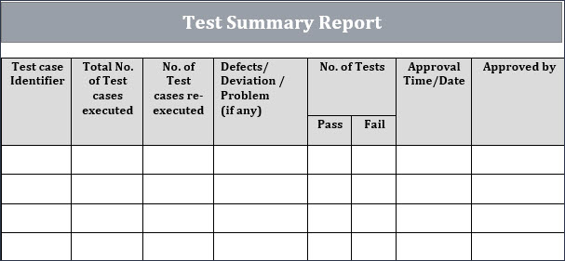

Test Defect Report
- Project Level Document
- Prepared By Test Lead
- In this all the defect found will be mentioned with their status.
- How many defect we have found, How many of them are been resolved and How many defects are open.
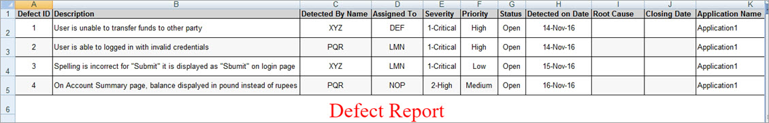

Test Closure Report
- Test Lead is responsible to make test closure report.
- Test Closure report provides a detail analysis of the type of testing carried out, process followed, the status of bugs found.
- To make test Closure report team lead use dash board tool.
- This report is in form of graphs.
- Test lead then send this report to Project Manager.

STLC – Software Testing Life Cycle
What is your organisations Test process?
What is STLC?
- STLC is a sequence of different activities performed by the testing time to ensure the quality of software or product.
- STLC is integral part of SDLC.

Defect sent to developer
Test Case execution
Test Plan
Test Initiation
Test Scenario/test case design

Test Summary/Closure Report

Test Initiation
It includes requirement of project , Scope of project, Risk involved in the project.
- Requirement of project – On which project domain we are working
- Scope of project – In this the strategies will be selected to test the functionality of modules present in the project.
- Risk involved in the project – Less resources, lack of knowledge, Less test data.

Test plan
- Resource Allocation – In resource allocation resources available for testing will be checked and which resource can perform which type of testing.
- Job allocation –In job allocation particular resource will be assigned with the particular task to complete the testing.
- Estimation – In Estimation it will be checked that how much time will be required to complete the single task or user story.

Test Scenario
- Test Scenario – What to test?
- From one user story/single requirement we can write multiple test scenarios.
- On customers requirement test scenario can be identified.
- From one test scenario we can write multiple test cases.

Test Cases/Test case design
- Test cases – How to test?
- On the basis of test scenario multiple positive and negative test cases can be designed.
- Test design is nothing but the test cases.

Test case Execution
- After test case design is completed we execute the test cases that we had written.
- While executing if we find any defect then that defect will be assigned to developer.
- Once that defect is fixed by developer and reassigned again to tester then we retest it.

Regression testing
- In test case execution the defect which we found we will be assigning it to developer , after fixing that defect from he developer side they will assign back this defect to tester and we will retest it.
- And after closing that defect we will be performing the regression testing on the application to check whether the fixed defect has impacted the applications other functionalities.

Test Summary Report
- Project Level Document.
- Document is prepared By tester.
- In this report we will be keeping the track of Test case design (TCD) , test case execution (TCE) , how many defects locked.

Test Closure Report
- Test Lead is responsible to make test closure report.
- Test Closure report provides a detail analysis of the type of testing carried out, process followed, the status of bugs found.
- To make test Closure report team lead use dash board tool.
- This report is in form of graphs.
- Test lead then send this report to Project Manager.

Q- What are the different types of level of testing?
In my organisation there are 4 levels of testing types.
- Level 0 – Smoke / sanity testing
- Level 1 – System and Functional Testing
- Level 2 – Regression Testing
- Level 3 – Final Regression Testing

Q- Test Suite, Test Bed, Test Set , Test Batch, Regression Suite
It is a collection of test cases or it is test procedure to be executed in a specific test run.

Test Plan
What is Test plan and what all it contains?

- Test plan is a project level document.
- Prepared By test lead.
- In this Test lead will be deciding the start date and release date of our project.
- During the Test plan We concentrates on Job allocation, Resource allocation and estimation.

Team Formation
- It is very initial Stage
- It focuses on following attributes while team formation
- Availability of resources
- Availability of environment resources
- Test Duration i.e estimation time

Risk Involved in the project
- Lack of resources
- Lack of Knowledge
- Lack of test data
- Lack of budget (Time and Cost)
- Delay in delivery
- Lack of communication Between dev and testers.
Prepare test Plan
After Completion of team formation and analyzation of risk, Test lead concentrates on preparation of test plan document.

How the Test plan is going to be prepared by TL?
TL is going to decide different components of test plan
- Test Plan Id
It is a Unique number or name to a particular test plan. Suppose we have to release the project on 8th month of 2022 , with the project name paytm and with its module transaction it is written as 2208_Paytm_Transaction.

- Iteration
What are the components included in your project.
Eg. Credit card , Debit card, Wallet, UPI, Net banking

- Test Items
Components /Module to test
What we need to test? Different functionality under particular module.
Eg . Credit card – Card no. , Expiry date , CVV, Card Holder name

- Features to test
It is a process in which we are going to test the features in it.
Eg. Credit card – CITI, HDFC, SBI, ICICI.

- Features not to be tested
This is nothing but what are the features we are not going to test in our release.

- Test Environment
SIT , UAT

- Suspension Criteria
Suspension Criteria means abnormal situation arise during test execution.
Eg. Database not working, Connectivity problem, blocker defect

- Test Deliverables
Providing testing documents to the client. It means without completing one phase we cannot proceed to the next phase.
Eg.Test report , Closure report , summary report

- Testing task
Which task will be perform by which tester>

- Staff and Training – KT

- Signature and Approval
Team lead is responsible to create test plan and then to verify it, TL reaches to project manager for approval.

What is Test Scenario and Test Cases?

Test Scenario For Pen
- Verify the company name
- Verify the colour of ink.
- Verify if pen can write on variety of papers eg. Rough or smooth pages
- Verify the grip of the pen
- Verify the pen with cap
- Verify the pen without cap
- Verify the material of the pen
- Verify the length and thickness of pen.
- Verify the type of pen
- Verify if pen writes smoothly
- Verify if other refil fits in pen or not
- Verify the tip of the pen
- Verify if the pen is mechanically clickable.
- Verify the written text by the pen
- Verify the look of the pen
- Verify waterproof ink
- Verify the usability of pen
- Verify how many characters can be written by a single refill
- Verify if ink do not get dry, if pen is open for some time.

Test Scenario For Water Bottle
- Verify the material of the bottle
- Verify the thickness and Strength of the bottle
- Verify the colour of bottle
- Verify the weight of bottle
- Verify the company name of bottle
- Verify the cap is leakage proof or not
- Verify the water capacity of the bottle
- Verify bottle is reusable or not
- Verify the maximum temperature of water in bottle
- Verify bottle is transparent or not
- Verify if the bottle is thrown from height it gets break or not
- Verify the base of the bottle
- Verify the Threads of Cap and bottle
- Verify the Price tag and ISI mark on Bottle
- Verify the plastic quality number of bottle
- Verify the bottle under various temperature

Q- Where we are writing the test cases?
In my Organisation we are writing test cases in excel sheet or in Project management tool(Jira/HpAlm).

Q- What is the format of test cases?
- Sr.no
- Test Case id
- Priority
- Test Case Scenario
- Test Cases
- Test Steps
- Expected Result
- Actual result
- Pass/Fail
- Comments/Suggestions
- Screenshots

Q- Where we are writing the test cases?
In my Organisation we are writing test cases in excel sheet or in Project management tool(Jira/HpAlm).

Q- What is the format of test cases?
- Sr.no
- Test Case id
- Priority
- Test Case Scenario
- Test Cases
- Test Steps
- Expected Result
- Actual result
- Pass/Fail
- Comments/Suggestions
- Screenshots

Write the test cases for following things?
- Chair, table, pen , fan , Bottle , Watch
- Flipkart, amazon
- Whatsapp, Instagram , Gmail, FB etc

Test Cases for references
https://artoftesting.com

Q- Which test cases we will consider as good test cases?
- It should cover all the functionalities of the application.
- It should be specific.
- It should be simple.
- It should be easy understand
- It should be precise(Exact or accurate)

Test Case Review
Review – It is nothing but to check the correctness and completeness of the test case document.

There are 4 types of review
- Self review
- Peer review
- Internal Review
- External review

Self review– In this review tester itself will review his all test cases.

Peer review – In this review our colleague or senior tester will review our test cases. We mail this test case document to our colleague or senior tester to review it.

Internal review – In this review BA person will review the test cases. In my project I was arranging the meeting with BA for test case review.

External Review – In this client or UAT team will review the test cases.

If we get any suggestion or comments in review process(peer, internal , external) we will add that in column of suggestions and comments present in test case excel sheet.

Q- Which things will be considered in test case review?
In test case review we focuses on
- Test cases should cover all the functionalities
- Complete user story should be covered.
- Spelling Mistake
- Simplicity of the test cases.
- All the +ve and -ve scenarios are covered or not.
- Duplicate / Repetition of test cases should not be there.
- Proper test case format should be followed.
- Grammar

Q- What is traceability matrix?
- It is also called as RTM (Requirement Traceability matrix) or CRM (Cross reference Matrix)
- In traceability matrix test cases and defects are mapped/linked with the requirement or user story.
- This document is designed to make sure that each requirement has a test case. It is prepared before the test execution process.
- The test engineer will prepare TM for their respective assigned module, and then it will be sent to test lead. Then test lead consolidate all prepare one TM for the project.
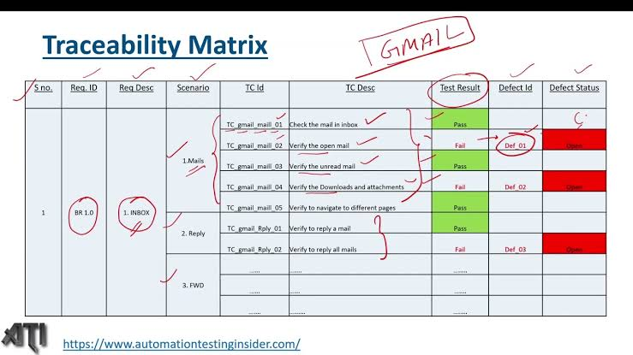

There are two types of traceability matrix
- Forward traceability matrix
- Reverse/Backward traceability matrix

Forward traceability matrix
In forward traceability matrix test cases are mapped/linked with the user story or requirement.

Why we do forward traceability matrix?
How many test cases I have written and not a single. test case should be missed as per the requirement mentioned in the user story.

Backward traceability matrix
In backward traceability defects are mapped or linked with the user story or requirement.

Why we do backward traceability matrix?
To know which defect belongs to which user story or requirement.

Traceability matrix will be prepared in excel sheet or project management tool (Jira/HpAlm)

Defect Life Cycle/Bug Life Cycle
Defect life cycle is a cycle which a defect goes through during its lifetime. It starts when defect is found and ends when defect is closed, after ensuring it’s not reproduced.

Reopen
FIX
Closed

OPEN
Reject
NEW

Differed

Tester Developer Tester

New – When tester locks the defect in Defect tracking tool then he marks the status of that defect as new.

Open – When developer will do analysis on defect then the developer will mark status of defect as open

When Developer do analysis on defect after that he has choices

Reject – If that defect is not valid defect, then he will mark the status of that defect as reject

Differed – If a defect is valid but developer don’t want to fix that defect in current sprint then he will mark status of that defect as differed.

Who will decide the differed defects – BA or PM

Fix – If a defect is valid then developer will fix that defect and then he will mark status of defect as fix.

Closed – When developer will fix the defect and reassign that defect to tester for retesting then the tester will retest it and if the defect is fixed, he will mark the status of that defect as closed.

Reopen – When developer will fix the defect and send it for retesting and if again that defect arises tester will reopen it and then he will mark the status of defect as reopen and will assign it back to developer.

Q- What is Duplicate Defect?
If the defect is repeated twice or same defect is raised by the different testers then it is called as duplicate defect.

Q- What is error guessing?
- It is one of the test case design technique which is done by one of the experienced person where he is going to guess the error.
- For this testing skilled and experienced person is required.

Q- What is Defect Seeding?
- When Developer add any defect intentionally in coding then it is called as defect Seeding.
- It is done to check whether tester is able to find that defect or not.

Q- Bug Leakage / Defect Leakage
When Tester misses any bug / defect and that is found by the end user , after the release of the application.

Q- Bug Release
When we released any version of an application or software with a group of some known bugs or issues the it is called as bug release.

Q- Defect Cascading?
- Defect Occurred due to another defect
- When a defect is present in any stage but it is not identified or noticed this will result in number of defects which is called as defect cascading.

Q- Defect Age
We can say that it is a time span of defect detection to defect fixing is called as defect age.

Q- What is failure?
Defect Found after the Delivery of the application.

Q- What is Pesticide paradox?
When Some set of test cases are executed again and again over a period of time then this set of test cases are not able to find new defects in the application.

Q- Defect Clustering?
We can say that in the small modules we are getting number of defects that is called as defect clustering.

Q- How many reports were there in your project and in which report you were involved?
Yes in My organisation I was generating the reports
- Test Report / Test Proof – During execution of test cases – Tester
- Defect Report - Tester
- Traceability matrix
- Test Summary Report – Tester
- Test Closure report – Test lead

Q- What were your roles and responsibilities as a Manual Tester?
- Requirement Analysis – SRS Analysis –1 User Story (If doubt – Grooming Meeting)
- Test Scenario Identification from US
- Test Case design
- Test Case review
- Test Case Execution
- Defect Report
- Traceability matrix
- Test Summary report
- Client Interaction – In Sprint review meeting – In My organisation I was giving review to the client.

Q- When would you come to know that your testing is completed?
- All the test case execution is completed.
- Whatever defect you have found while doing the execution are rested and closed.
- All defects resolved
- Traceability matrix prepared
- Test Summary report submitted to test lead.
- By looking at the above terms I would say that I have completed the testing.

Q- How many test cases you have designed and executed per day?
- It completely depends On the complexity of the application.
- In Manual testing TCD per day 30 to 40 test cases.
- On an average Test Case execution per day – 20 to 25 test cases

Q- How many defects you have locked per requirement?
- It depends on the user story which I am testing,
- On an average I am locking 3 to 4 defects per user story
- If user story is not properly developed then I will get more defect – In my carrier in last project for one of the user story i have found more defect – For one user story i found 9n to 10 defects
- If user story is properly developed then we will get less number of defects that are 1 or 2 defects.

Q- If developers are not accepting your defect, what will be your approach?
- I will first lock the defect in defect tracking tool with proper description and snapshot. Then I will send this mail to developer.
- If still Developer is not accepting the defect the I will check from my side the defect raised by me is correct or not as per the requirement.
- If still developer is not accepting the defect, then I will Share my screen and I will show him what exactly the defect is.
- Still developer is not accepting my defect then I will raise this issue in daily stand up meeting.

The END

